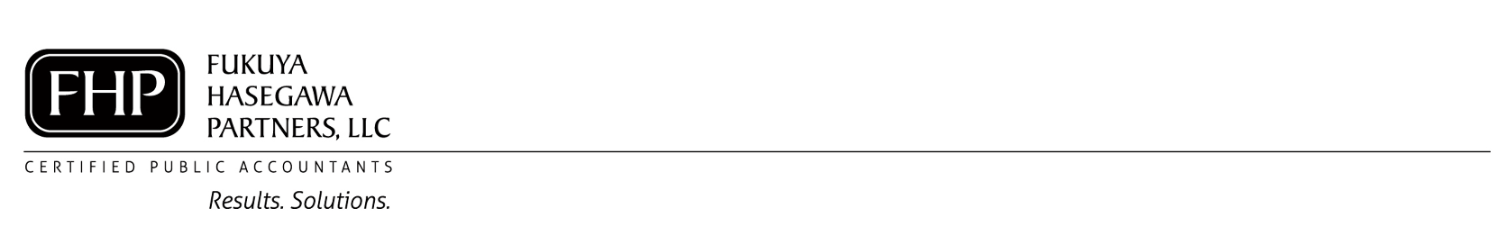
Tax Internship – Honolulu CPA Firm
📍 Location: Honolulu, HI
Launch your accounting career with hands-on experience this tax season—while getting paid to learn!
We are looking for motivated interns to join our team from February through mid-April. This is a unique opportunity to gain real-world tax experience while working in a supportive, professional environment.

Dates: February 1 to April 15
Hours: Minimum 20 hours per week
Spring Break: Full-time availability (40 hours) required

What You’ll Do:
- Prepare individual income tax returns
- Collaborate with a team of professionals and learn directly from experienced CPAs
What You’ll Gain:
- Paid internship experience
- Group training + one-on-one mentorship
- Hands-on experience in a CPA firm setting
- Skills in communication, professionalism, and project management
- Resume-building experience with opportunities for part-time or full-time employment
What We’re Looking For:
- Positive, professional attitude
- Strong communication skills
- Attention to detail and motivation to learn
📧 To Apply:
Send your cover letter, resume, and references to CPA@fhpcpas.com

Check out our Facebook page!

